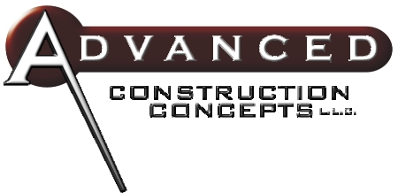
Are you anticipating another exciting building season this year? We are and we’d like to help you get through the building season in a faster, safer, more profitable way!

Will you please take a moment to learn how we can help you to become more profitable and provide better houses for your clients?

We are Rough Framing Specialists Our unique on-site fabrication and erection system saves you material, time and money!

On-Site Panelization is a system that eliminates waste, the same way that they do it in the factories.

We Use Less Materials, you SAVE MONEY!

We meet or exceed production schedules, guaranteed! On-site panelization allows us to start the house before the garage foundation is laid without interfering in that process!

36716 Melbourne

Sterling Height’s, MI 48312

Fax: 586.446.9411

Frank Coscione 586.615.5800 Jim Allen 586.292.7974
Carpenters Who Care

