Solar Concentrator Experiment

Patrick J. George, NASA Glenn Research Center, Cleveland, OH
Arthur Brockschmidt, Boeing Phantom Works, Seattle, WA
Robert Matson, Boeing Phantom Works, Seattle, WA
Ishaque S. Mehdi, Boeing Phantom Works, Seattle, WA
Mark O’Neill, ENTECH, Inc. , Keller, Texas

Abstract

This paper describes the design, development, fabrication, and test of a high-performance, high-voltage solar concentrator array. This assembly is believed to be the first-ever terrestrial multi-junction-cell solar array rated at over 1 kW. The concentrator provides over 200 W/square meter power output at a nominal 600 V (DC) while operating under terrestrial sunlight. An objective was for the electrical insulation system to operate as 2 600 volt photovoltaic arrays in series to enable direct powering of ion engines in space. Space-quality materials and fabrication techniques were used for the array, and the 3000 meter elevation installation below the Tropic of Cancer allowed testing as close as possible to space deployment without an actual launch. The array includes two concentrator modules, each with a 3 square meter aperture area. Each concentrator module uses a linear Fresnel lens to focus sunlight onto a photovoltaic receiver that uses 240 series-connected triple-junction solar cells. Lens aperture width is 84 cm and the cell active width is 3.2 cm, corresponding to a geometric concentration ratio of 26X. The evaluation includes the concentrator modules, the solar cells, and the materials and techniques used to attach the solar cells to the receiver heat sink. For terrestrial applications, a finned aluminum extrusion was used for the heat sink for the solar cells, and maintains a low a temperature so that solar cell efficiency remains high.

Introduction

Recent Space Solar Power studies [1] have indicated that high voltage arrays could dramatically reduce the mass of a large power generating spacecraft designed to beam power to Earth. Lower mass has a leading effect on reducing launch costs and would therefore make the concept more feasible from an economic point of view. In addition, the benefits of a high-voltage system extend to all spacecraft having a significant portion of their mass taken up with wiring for collection of electrical power from arrays and power management including conversion and transmission to various systems. Other applications include providing power for “direct” drive for electric propulsion thrusters.

The goal of this experiment was to investigate the issues associated with operating high voltage arrays in space and test some possible techniques to solve the problems. Analysis indicated a major problem with high-voltage arrays was electrical isolation of the cells while allowing sufficient heat transfer away from the cells so that they remain cooler and closer to their maximum efficiency point. This problem was selected as the focal point of the experiment.

While the experiment could be performed in a laboratory under controlled conditions, it was decided to take advantage of some existing equipment, build whatever else was needed and perform the experiment under actual conditions. This decision sparked greater ideas, such as making this the first part of a complete end-to-end system test to beam power over a distance. Analysis of terrestrial data would allow projections of the probable performance in space. The ultimate purpose would be to investigate the interface issues and gain insight to operating a power beaming system in space.

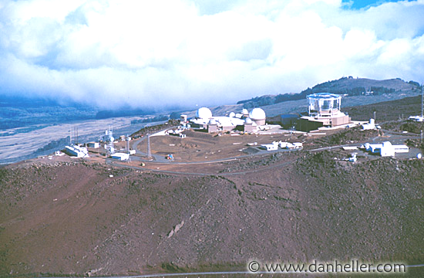
Funding and time limitations ruled out a test in space. Therefore, a terrestrial test site was sought which would provide exposure to the most space-like
Figure 1. Maui Space Surveillance System (MSSS) and other telescopes on Haleakala, Maui, Hawaii

solar spectrum. A number of test sites were considered with access roads to high elevations, but only one turned out to meet all requirements including the protection of a local U.S. government operation. Mt. Haleakala on the Hawaiian island of Maui has a peak of 3005 meters and a two lane paved road leading to the top, which enables tourists to view the dormant volcanic crater. A number of telescopes are operated from a restricted site close to the peak. The site is home to the Maui Space Surveillance System, operated by the U.S. Air Force, and other telescopes owned and operated by civilian groups.

Before taking on the task and expense to ship equipment to Hawaii, we investigated the content of the solar spectrum at the proposed site and compared it to sea level and space environments using SMART2 [2].

The solar spectrum on Haleakala was predicted to show an overall content of Air Mass (AM) = 0.2 (actual 0.1975) [3] The Air Mass value corresponds to the relative optical thickness of the atmosphere, with AM=1 corresponding to a sea level location on the Earth’s surface with the sun directly overhead, and AM=0 corresponding to space sunlight for an earth-orbiting spacecraft. Compared to sea level locations, the Haleakala location allows significantly more of the short-wavelength radiation to reach the site, including potentially damaging ultraviolet wavelengths below 400 nm.

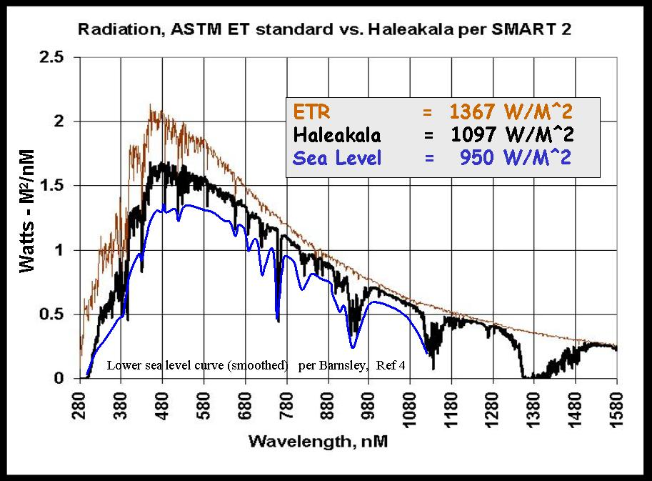
The operating voltage level was selected to be in the range of 1200 volts. This would enable direct drive to ion thrusters and lower conversion losses to HV microwave transmitters. Presently, one of the higher voltages used in space is the International Space Station array at 160v., Arcing due to outgassing and plasma charging have been among the problems encountered with that lower voltage level, so one of the objectives was for the cell mounting system to have no exposed conductors. The team decided on building and testing the insulation system for an operational level of 1200v and a test level of 3200V. Previous development work on high-voltage arrays [4] was used for guidelnes.
Figure 2. Comparison of insolation and solar spectrum

A concentrator-type array was selected for several reasons. First, the high unit cost ($/cm² of triple-junction solar cells would have been cost-prohibitive for a planar array of a 1 kW. Second, concentrator arrays have substantial advantages in high-voltage space solar arrays, because the small photovoltaic cell circuit can be super-insulated with very little mass impact on the overall array. Third, the 26X concentration provides an intensified thermal stress on the cell circuit and on the cell-to-heat sink bonding, enhancing the value of the experiment. This experiment tested the thermal and dielectric capabilities of the assembly approach, which, coupled with the large air-cooled heat sink, successfully kept the cell temperature from reaching excessive levels.

Multi-junction solar cells were the choice for the power generation source because of traceability to high power space operation, capability for high efficiency, and the potential for space missions including a solar power satellite.

The third objective of the experiment was to promote the use of high-voltage arrays in space by defining a manufacturing method which utilized the best known techniques to bond the cells to the receiver and yet was not “exotic”, and possibly expensive, but usable by the general aerospace community,
Two methods of a set of candidate cell attachment or “lay-down” techniques were chosen and applied to the modules for test.

This paper describes the manufacturing methods utilized, the construction of the arrays, their installation and the results of the experiment.

SunLine Concentrator Array

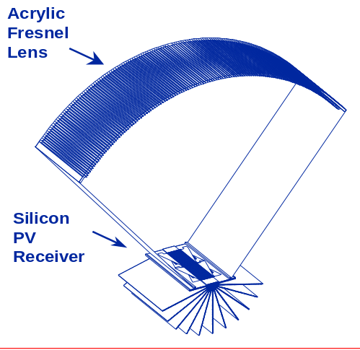
ENTECH has been involved in photovoltaic concentrator technology for terrestrial applications for many years [O-1-O-3]. Figure 3 shows ENTECH’s fourth-generation silicon-cell-based terrestrial concentrator module, which uses a large acrylic Fresnel lens (84 cm wide) to focus sunlight at 21X concentration onto air-cooled silicon photovoltaic cells (4 cm wide). The acrylic lens is smooth on the outside and and prismatic on the inside, with a unique arch shape that maximizes both optical performance and error tolerance (O-1 and O-2). Remarkably, compared to conventional solar concentrators using reflective surfaces or flat Fresnel lenses, this lens provides more than 100 times better shape error tolerance, which is very important for reliable, long-term operation in the harsh outdoor environment. The cells are maintained approximately 25C above the ambient air temperature by a finned aluminum heat sink, which provides 4 times more convective heat transfer area than the aperture area of the lens. This ratio of heat transfer area to heat collection area is the most important parameter for determining cell operating temperature, and a conventional one-sun flat-plate photovoltaic module has a ratio of 2 for an open-back frame mount, or 1 for a roof-mounted system. Due to this large extruded heat sink, the cell temperature for the 21X module is about the same as for a frame-mounted flat-plate module, and cooler than for a roof-mounted flat-plate module. The solar cells are attached to the heat sink materials that have a high electrical resistance and a low thermal resistance, to prevent electrical shorts to the heat sink (ground faults) while maintaining a cool cell temperature. In addition, the entire cell circuit is encapsulated for weather resistance, even though it is enclosed within an aluminum housing (side walls and end plates which are not shown in the figure). Each concentrator module has an aperture length of about 3.6 meters, providing an overall lens aperture area of about 3 square meters.
Figure 3. 21X Line-Focus Concentrator Module

These large (3 sq.m. aperture) concentrator modules are mounted in two-axis sun-tracking arrays. For remote and residential applications, ENTECH has developed a small array containing two modules called a SunLine®, as shown in Figure 4. This SunLine array uses two identical linear actuators to implement two-axis sun tracking. One of these actuators tilts the galvanized steel frame from north to south (and vice versa) to follow the sun’s apparent motion in this direction. The second actuator rotates the two modules from east to west to follow the sun-s apparent motion in this direction. Both actuators are powered by 12 Volt (DC) motors, which are equipped with rotating magnet wheels and switches to count the number of motor rotations to provide position feedback to a microprocessor-based open-loop controller. The microprocessor uses a simple program to calculate the sun’s position within 0.01 degree in each axis, based on the time and date and the local latitude and longitude. The controller and drive motors are powered by a 12 Volt (DC) battery (two 6 Volt golf cart batteries in series) which is trickle-charged by a 5 Watt flat-plate photovoltaic panel attached to the north end of the SunLine structure. A simple wind switch, comprising a mercury switch inside a drag device suspended by the electrical cable, is used to tell the controller to return the array to its safest stow condition (horizontal tilt and full east roll) whenever the wind speed exceeds about 30 mph (50 km/hour). SunLines have been installed and continuously operated for 10 years in Texas, 9 years in Minnesota, and multi-year periods in several other locations around the country. The units are autonomous, except for periodic (about every six months) clock setting and normal maintenance (e.g., battery water check every year).
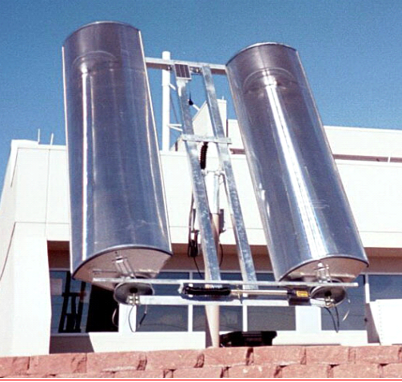
Figure 4. Small SunLine Array
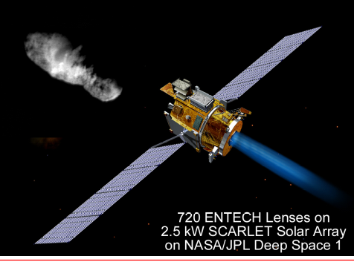
ENTECH has also been involved in photovoltaic concentrator technology for space applications for many years, (O-4-O-10). The award-winning SCARLET array on Deep Space 1 (Figure 5) provided space validation for the concentrator array, which has since evolved into the ultra-light Stretched Lens Array (Figure 6). For space applications, the environment is drastically different, and high performance and low mass are far more critical than for terrestrial applications, leading to a totally different configuration for space concentrators. The space Fresnel lenses are small (8.5 cm aperture width) and made of very thin (150 micron), flexible, space-qualified silicone (DC 93-500). The heat rejection radiators are similarly very thin (125 micron) carbon fiber fabric rigidized with cyanate resin. A near-term rigid-panel version of the Stretched Lens Array (SLA) offers 180 W/kg array-level specific power, a mid-term flexible-blanket version will offer over 500 W/kg, and a long-term version is expected to offer over 1,000 W/kg (O-10). All versions of SLA also offer unprecedented high-voltage operation of the photovoltaic receiver circuits.
Figure 5. SCARLET Concentrator Array on Deep Space 1

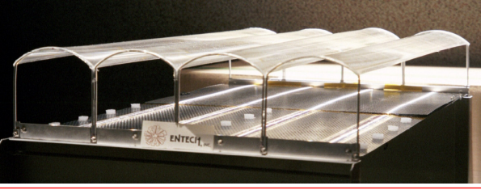
For the solar concentrator experiment which is the subject of this paper, a convergence of the terrestrial and space concentrator technologies provided the best combination of cost-effectiveness, performance, and durability for the ground environment. The robust terrestrial module (Fig. O-1) and the field-proven SunLine array (Fig. O-2) served as the baseline hardware for the experiment. However, the normal silicon cells used on the photovoltaic receiver were replaced with much higher performing triple-junction solar cells (GaInP/GaAs/Ge). The normal lens was likewise replaced with a new color-mixing Fresnel lens [O-6] to preclude chromatic aberration losses (due to prismatic dispersion in the lens coupled with the three separate spectral response regions of the series-connected triple-junction solar cells). With these two major exceptions (solar cells and lenses), the concentrator module configuration and the SunLine array configuration remained the same as successfully used in previous installations. Since the basic color-mixing lens technology and multi-junction cell technology used in this concentrator experiment also form the basis of the Stretched Lens Array (SLA) used in space (with the exception of scale and materials), results of this ground test are easily extrpolatable to future space concentrator arrays. In addition, the results of this concentrator experiment lay the foundation for a future terrestrial concentrator arrays, using color-mixing lenses and multi-junction cells to achieve unprecedented performance and later cost effectiveness in mass production. Thus, this unique solar concentrator experiment provides important data supporting the development of advanced versions of both space and terrestrial photovoltaic concentrators.
Figure 6. Stretched Lens Array (SLA)

Solar Cell Receivers

Each photovoltaic receiver (also referred to as a module) is composed of an extruded aluminum heat sink, thermally conductive electrical insulating layer, the solar cells and bypass diodes, the cover glass, and external connections. The deleterious effects of space plasma on high voltage solar arrays are well known. A basic objective for array fabrication was to provide a full electrical 3200 plus volt electrical insulation for each solar receiver while maintaining high thermal conductivity and providing for thermal expansion. One standard electrical insulation qualification test for terrestrial photovoltaic modules of all types corresponds to a wet hi-pot test at twice the maximum rated operating voltage plus 1,000 Volts. Thus, for a 600 Volt rating, a wet hi-pot test at 2,200 Volts would have met this requirement, but it was decided to add an additional 1,000 Volts to the wet hi-pot test for this program.

The initial task was selection of the solar cells. As discussed above, triple junction cells were a basic part of this experiment. Schedule and budget constraint led to the use of existing cell aspect ratios, and a Spectrolab GaAs P/N 95543-002 cells were selected. As discussed above, the ENTECH concentrator module, including the color-mixing acrylic line-focus Fresnel lens optical concentrator element, is designed for a geometric concentration ratio of 21X, corresponding to a lens aperture width of 84 cm and a cell active wide of 4.0 cm. This cell width provides excellent optical interception of the focused sunlight as well as a sun-pointing tolerance of about 0.5 degree [11]. Unfortunately, schedule and budget constraints dictated the use of narrower cells, with a significant optical interception penalty even for perfect sun pointing, and drastically reduced sun-pointing tolerance compared to the normal wider cell. In addition, the selected cell had its busbar running across the focal line of the lens, instead of parallel to the focal line on the two outer edges of the solar cell. This non-optimal cell configuration led to a substantial loss of photons which intercepted the busbar and end tab rather than active solar cell material, causing an additional performance penalty. For future systems, with wider cells and edge busbars and interconnect tabs, power output will be at least 20% higher, not including anticipated cell efficiency improvements.
The basic concern for cell attachment to the heat sinks was the inter-relationship of thermal and electrical conductivity. The spreadsheet charts of Table I illustrate one of the trades made for the design of the solar cell installation. As can be seen from the table, the use of high thermal conductivity polyimide for electrical insulation provided for over 30 C lower solar cell temperature with corresponding improvement in efficiency. The full insulation system was comprised of layers of thermally conductive polyimide (Kapton MT) and thermally conductive silicone (Chothem and Loctite 5406). Both full load and no load thermal conditions were addressed.

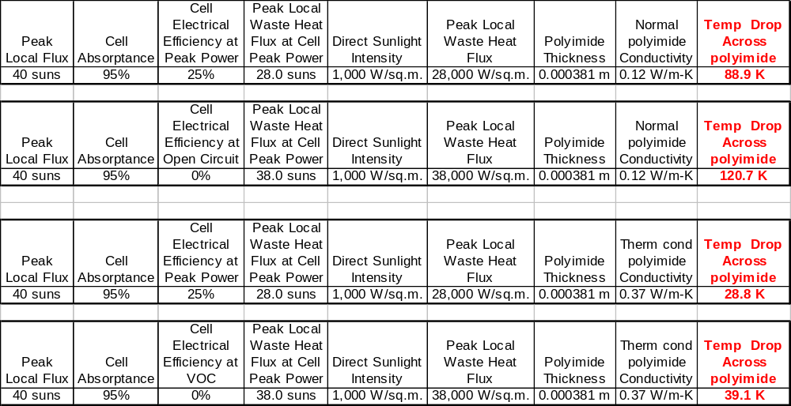
Table I, thermal vs. electrical conductive trades

To achieve the thermal conductivity levels shown in the table, it was essential that the cell-mounting surface be flat to prevent excessive silicone thickness. The aluminum extrusions were previously designed for use with stronger and more flexible silicon cells (using edge tab connections) and thus had a plateau on the cell mounting surface with reliefs on either side to provide room for the edge tab connectors and bypass diodes. For the present end-tab-connected multi-junction cell circuits, these plateaus were a problem, as was a lengthwise bow on the 12-foot-long extrusions that precluded removal of the plateau with a planer. The cell mounting surfaces were thus flattened with hand files and scrapers.

The 2 array receivers were fabricated with slightly different techniques. 2 layers of polyimide were used to avoid single point dielectric failure. An initial material study showed that Chotherm 1641 has one of the better thermal conductivities (0.90 W-m/K) of filled silicones, so that material was used with Kapton MT on the first unit. The thickness of the silicone layer was to be spread at a thickness of 0.07 mm by using temporary tape as a guide for a screed. Initially both units were going to be fabricated with the same materials. Unfortunately, the Chotherm (CT) 1641 had lumps of oxide that could puncture the 0.038 mm polyimide layer or cause cell cracking. The oxide ‘rocks’of up to 0.2 mm in diameter had to be removed by hand. The CT 1641 was also could not be spread layers thinner that 0.2 mm, 3 times the initial design value. After further material searches, we found that Loctite 5406 was capable of being spread to less than 0.07 mm thick. The Loctite 5406 has a lesser thermal conductivity of 0.7 W-m/K, but as it could reliably be spread thinner, overall conductivity was greater than the CT 1641, so CT1641 usage was discontinued. The test data section will describe the improved performance with the Loctite 5406 silicone. The final dielectric layer was thus silicone-polyimide-silicone-polyimide-silicone. The dielectric layer was tested to 3,200 volts.
The cells were assembled by hand in strings of 12 each, and 20 of these strings were laded onto the dielectric layer. Cell attachment was performed by screeding a layer of Loctite 5406 thru widow screening, and laying the 12 cell strings onto that bed (Figure 7) and seating through the use of airbags applied to the surface of the cells. The cell surface was protected with lint free tissue.
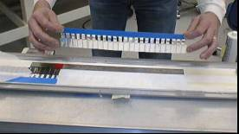
After the silicone cured, the 12 cells strings were connected with silver solder and end terminations provided. Each cell was provided with a silver tab to which a parallel connected surface mount diode was attached for protection. The diodes were installed outside the concentrator beam. Figure zxc shows one of the strings of 12 cells being placed on the screeded layer of silicone.
Figure 7. Laying a cell string
The final step in receiver assembly was installation of the UV transmissive cover glass. The cover glass was obtained in lengths to just cover a string of 12 cells. Cover glass attachment was with space qualified Dow Corning DC 93-500 silicone. We found that the activator (Loctite 7357) for the adhesive used to attach the bypass diodes poisoned the Pt catalyst of the DC 93-500, and additional catalyst needed to be used.

As the Haleakala site location was a restricted area, we could not install any ties to the commercial power grid, either for supplying the solar power to the grid or to power monitoring equipment. To monitor the performance of the concentrators, a data logger and load bank was constructed using simple 600 + volt resistive loads. Voltages and currents for each array were monitored with an A/D module and recorded once every second onto a laptop computer installed in an industrial enclosure. The enclosure featured a digital readout of voltage and current. Additionally, 8 thermocouples also were installed to record array temperatures every second. The 600 volts per concentrator was down converted to charge a 100 A-hr 14.4 volt battery to provide laptop power. The battery was capable of 8 days operation without recharge. Due to safety concerns, the arrays were operated in parallel rather than series as originally planned. A fence had been planned to address the safety issues, but was not allowed due to the possibility of an endangered night flying plover flying into the fence. Since there could not be a fence, all of the data logger and load bank wiring was double insulated for safety and the arrays run to separate load banks at 600 Vdc.

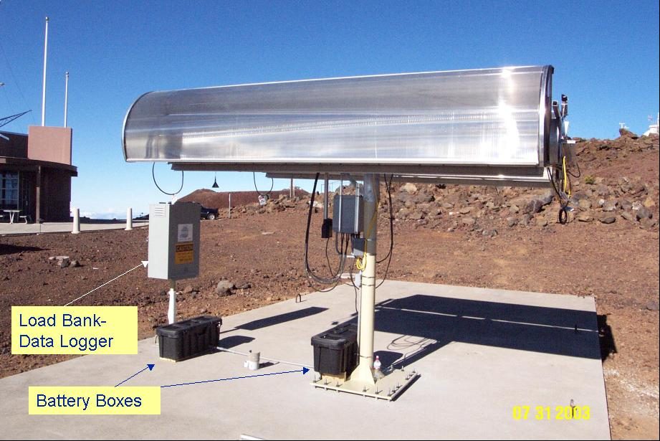
Site Location
Figure 8. Haleakala assembly

The concentrating array assemblies and data logging equipment were installed at the summit of Mt. Haleakala, on the island of Maui, Hawaii, at an elevation of approximately 10,000 feet. The support structures were bolted to an existing concrete pad, previously used by University of Hawaii, Institute for Astronomy backup power generators. The pad is 18’x50’, the length running in a near-perfect east to west direction, and very level. Figure 8 shows the assembly in operation late in the afternoon of July 31, 2003. The view is from the southwest corner, looking east and north.

Results

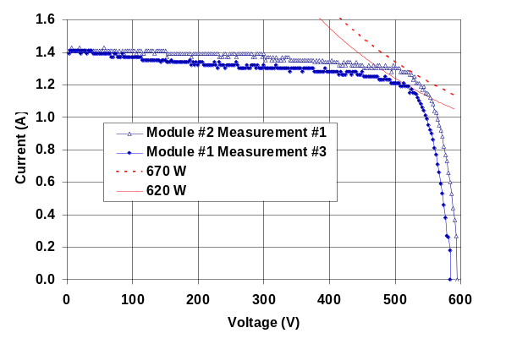
A curve tracer was used on July 31 (the week after Lahaina noon [7]) to determine performance. Figure 9 shows the results of that test. The curve tracer was limited to 600 volts. It was immediately apparent that Module#2, constructed with Loctite 5406 silicone, was cooler and a much better performer that the first unit fabricated. In fact, Module #2 had to have its heat sink insulated for the test to reduce the open circuit voltage to below 600 volts. A pryheliometer was used to assess the insolation level at the time of the test, and indicated up to 1097 W-m² levels.
Figure 9. Array curve traces.
Typical energy output was 16 kW-hrs per day. In normal operation, the Module# 2 heat sink was typically at 28C to 34C, while the Module #1 heat sink was 2 to 3C higher.

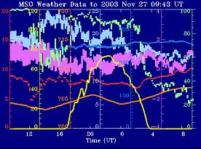
The major problem encountered in operation was wind. We were able to correlate weather conditions with power outages through the use of data from the Mees observatory weather station located within a few hundred meters of the arrays. The concentrators have a self protection mechanism for going into a stow position during periods of high wind. Figure 10 [6] is an example of a high wind condition that caused the array to stow. Refer to the web reference for details of the curves.
Figure 10. MEES weather data

Figure 11 is a printout of the data for each array as recorded on the laptop computer. It can bee seen from the chart that power output consistently peaked at over 600 watts during periods of peak insolation and low wind.

Due to severe mountain top winds during December thru April, it was decided to remove the arrays to storage during that period. During removal from the test site on 3 Dec 2003, an inspection was performed. The major damage was that the wind sensor had literally been blown off the tracking mechanism during a late November storm and that wind driven rain was intense enough to defeat louvers and seals on the electrical panels.
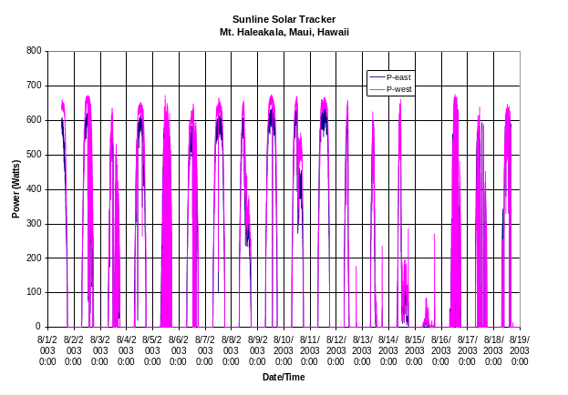
A close inspection of the solar array when the units were taken to storage showed complete integrity of the solar cell , heat sink, and cover glass assembly.
Figure 11. Daily power production plot

Based on the test results and further study of the concentrating array configuration, it will be possible to increase the power output up to20 % to 30 % by optimizing concentration ratios, cell arrangement, and further thermal management improvements. The existing aspect ratio cells used were 20% narrower than the design cell width matched to the concentrator lens, and the end busbars and end tabs intercepted (and wasted) a significant amount of the concentrated sunlight in the continuous focal line produced by the lens. Optimizing the cell width and replacing the cell end busbars with dual side busbars (enabling tabs and interconnects to be placed outside the focal line) would alone add more than 20% to the power output. In addition, the dual busbar configuration reduces electrical resistance losses in the solar cells, also boosting conversion efficiency. Other possible performance-boosting features of future arrays include prismatic cell covers to eliminate gridline shadowing losses on the cells, and means to reduce the loss of photons in the gap between cells. Improved methods of laminating silicone and conductive polyimide will reduce thermal rise and improve cell performance.

design guidelines for high-voltage concentrator arrays

Many of these are re-learned lessons, all are included to illustrate how even basic items can be overlooked when more interesting technical efforts are being performed. Some previous lessons learned that were successfully followed are also included. This is a simple list of single sentence lessons learned.
- Put even big extrusions in a box when shipping – a forklift tore the fins on one heat sink.
- Don’t assume any commercial filled silicone was adequately screened before filling – e.g ‘rocks’.
- As always, simple thermal models do work and are useful, such as the array thermal model.
- When using a Pt catalyst silicone, especially the hypersensitive DC 93-500, test and retest EVERY item it touches for poisoning.
- Use of simple hand tools is often simpler and lower cost than machining – e.g. smoothing extrusions.
- Physical mockups are invaluable, especially when the installation is at a remote site.
- The person(s) installing an array at a remote site should participate in the mockup.
- Avoid “Hubble scenarios”, test every item in an assembled configuration before shipping.
- Rain driven at 130 km/hr will get into most any commercial equipment enclosure.
- The unique environment on Haleakala (especially high winds nearly every day and wind-driven rain during storms) caused sun-tracking problems which had not been experienced on the same type of SunLine array in a decade of testing at other locations, including Minnesota, New Mexico, Texas, Colorado, Ohio, etc. Improved junction boxes, conformal coatings on circuit boards, and stronger wind speed sensors are some of the items which will be implemented at Haleakala in the future.

Conclusions

We believe that the experiment has successfully demonstrated the ability of the concentrator to operate at high voltages. Further refinements will make the concepts developed during this solar concentrator experiment usable for space applications, allowing for large weight reductions for ion thrust systems and power beaming.

Impacts to Space Solar Power and Future Plans
Results of this test show that operation of high voltage arrays should be considered a viable method of reducing spacecraft mass and volume. Any Space Solar Power spacecraft design should include a system trade study on the most appropriate voltage for arrays, power management and other sub-systems.
The test was also considered to be the first phase of an end-to-end power beaming demonstration. The second phase is to expand this test to include a high efficiency power converter unit. The third phase provides for the attachment of a power transporter device such as a microwave or laser of modest power (1kW) to beam power over both short and long distances. The forth and final phase would be to design a high efficiency photovoltaic array and/or rectenna to receive the beamed power. At this stage, a complete end-to-end system will have been assembled and valuable information learned regarding the interface problems between sub-systems. This information would go a long way to understanding the complexities we would face in constructing a large Space Solar Power system.
The high-efficiency power converter has already been designed and packaged. Installation at the test site will be possible as soon as funds become available. Efforts to obtain funding for the development of level the next generation of arrays to improve the efficiency and increase the overall system power are already underway.
After the completion of the ground tests to refine the design, the next obvious step is to confirm the results with a flight test.

References
1. Advanced High Voltage Solar Array Design Guidelines from Solar Tile Testing
Contract No. NAS8-99191 With NASA Glenn Research Center
Under NRA8-23 Space Solar Power Exploratory Research and Technology (SERT) Program October 31, 2001
Principal Investigator: Brian J. Reed Boeing Phantom Works
P.O. Box 3999, MC 38R-59 , Seattle, Washington 98124-2499
(253) 657-3001; FAX (253) 773-8846 e-mail: brian.j.reed@boeing.com
Co-Investigator: Dr. Dale Ferguson
NASA Glenn Research Center
21000 Brookpark Rd, Cleveland, OHIO 44135
(216) 433-2298 e-mail: ferguson@lerc.nasa.gov
2. Smart 2 solar spectrum model, http://rredc.nrel.gov/solar/models/SMARTS/

3. Air mass zero (AM0) describes solar irradiance in space, where it is unaffected by the atmosphere. The power density of AM1 light is about 1000 W/m²; the power density of AM0 light about 1360 /m².
Reference: http://www.bpsolar.com/ContentPage.cfm?page=18
4. Flora, C. Bauman, S. “Advanced solar tile design and performance”, IEEE Aerospace Conference Proceedings, 2002.
5. http://stress.swan.ac.uk/~mbarnsle/teaching/envmod04/lectures/solar_radiation_present2.pdf
6. Mees Solar Observatory All Data Search; http://www.solar.ifa.hawaii.edu/All/search.html
7. Lahaina noon; http://www.ifa.hawaii.edu/info/vis/misc_info.html

O-1] "Solar Concentrator and Energy Collection System," U.S. Patent No. 4,069,812, 1978.
[O-2] Partain, L, “Solar Cells and Their Applications”, John Wiley & Sons, 1995
[O-3} A. J. McDanal, et. al., “Development of Terrestrial Concentrator Modules Using High-Efficiency Multi-Junction Solar Cells,” 29th IEEE PVSC, New Orleans, 2002.
[O-4] M.F. Piszczor , et. al., “Development of a Dome Fresnel Lens/Gallium Arsenide Photovoltaic Concentrator for Space Applications,” 19th IEEE-PVSC, 1987.
[O-5] M.J. O'Neill, “Line-Focus Optics for Multijunction Cells in Space Power Arrays,” 25th IEEE PVSC, Washington, 1996.
[O-6] “Color-Mixing Lens for Solar Concentrator System and Methods of Manufacture and Operation Thereof,” U.S. Patent 6,031,179, 2000.
[O-7 Carrigton C, et al., “The Stretched Lens Ultralight Concentrator Array,” 28th IEEE PVSC, Anchorage, 2000.
[O-8] “Stretched Fresnel Lens Solar Concentrator for Space Power,” U.S. Patent 6,075,200, 2000.
[O-9] George, P. J. , et al., “Development of the Ultra-Light Stretched Lens Array,” 29th IEEE PVSC, New Orleans, 2002.
{O-10} M.J. O’Neill, “1,000 W/kg Solar Concentrator Arrays for Far-Term Space Missions,” STAIF-2004, Albuquerque, 2004.

21. Kapton MT datasheet. http://www.dupont.com/kapton/products/H-38497-1.pdf
22. Loctite 5406 data sheet. http://www.loctite.com/datasheets/tds/Product_5406.pdf

23 CHO-THERM 1641
http://www.chomerics.com/products/documents/tb62.pdf

