Protect Your Investment!
Since 1984! |  | • Order Now - We've Made it easy!
Z-Stop® Quick Facts
• | A 50 foot long roll of Z-Stop sells for $55.00 |  | order here
• | Neoprene-washered Z-Stop nails are included
• | Z-Stop lasts 20+ years
• | Free Shipping in the Continental USA!
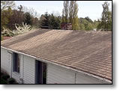 |  | The Problem:  You've just performed a costly roof repair, roofing remodel or roof cleaning. Looking around in your neighborhood you see one house after the other with a black or green discoloration on the roof shingles (roof moss or roof algae). If left untreated it will eventually destroy the roofing material.
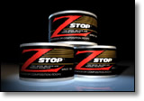 |  | The Solution:  Our success is in what you don't see! Z-Stop, a zinc strip that's easily installed on your roof, acts as a barrier to roof moss, algae and fungus growth, protecting the roof, its appearance and value. Z-Stop is a zinc roof moss, algae and fungus inhibitor that is applied in strips to old or new roofs. It works with any wood or composition roof. The natural action of rain water time-releases zinc carbonate, a proven fungistat, which then washes down the roof preventing destructive roof moss, algae and fungus growth.
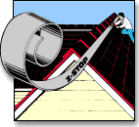 |  | Z-Stop is:
  • | VERY cost effective (especially compared to a roof repair or new roof)
  • | lasts 20+ years
  • | easy to install
  • | completely safe for roofing shingles (unless you're fungus, moss, algae or mildew)
  • | works better, lasts longer and is safer than roof cleaning and chemical moss control or moss killer
  • | works on any roofing material made of composition, flat tile, metal, shingles or cedar shakes
  • | an ideal product for both the do-it-yourselfer and the professional roofer.

__

________________________________________________________________________________________________________
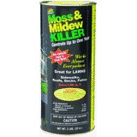

Share your own customer images
MATSON LLC #903 3LB Moss Killer
Other products by MATSON LLC

Bottom of Form

Product Description
Product Description
Moss B Ware, 3 LB, Moss Killer, Extends Life Of Roofs, & Improves The Condition Of Patios & Walkways, Won't Stain Roofs Or Corrode Aluminum & Galvanized Gutters If Uses As Directed, Use Any Time Of The Year, 99% Zinc Sulfate Monohydrate, Can Be Used On Structures Made Of Composition, Wood, Concrete, Metal, & Asphalt, For Decks, Roofs, Patios, & Walkways, Apply Either In Dry Form Or Mix With Water, Shaker Container.
________________________________________________________________________

Top of Form
United Industries #4340 40OZ RTS Moss Killer
Other products by UNITED INDUSTRIES CORP
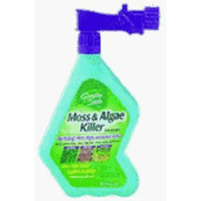

Share your own customer images

Product Description
Product Description
Garden Safe, 40 OZ, Ready To Spray, Moss & Algae Killer.
Potassium soap of fatty acids

Top of Form
Fungicide Roofs And Structures Moss Out Ready To
Lilly Miller Brands
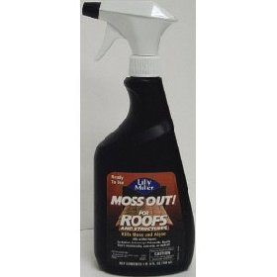

Share your own customer images

Bottom of Form

Product Description
Product Description
Moss Out for Roofs And Structures Kills Moss And Algae. - Ready to use fast acting Moss and Algae Killer. - Does not stain concrete or pavement. - Can be used at any time during the year.Active Ingredients: - Ammoniated Soap Of Fatty Acids - 3.68% - Inert Ingredients - 96.32%

