PRODUCT PROPOSAL

The purpose of this proposal is to disclose a product Idea for your consideration. Currently, there are two types of saws that dominate the construction industry. The miter saw for its ability to provide precise and repeatable cuts and the circular saw for its portability and capacity to rip long unrestricted lengths. However, with each of these advantages comes a significant disadvantage. In case of the miter saw, its significant weight and bulk require it be set up at a fixed location where the supply lumber must now be brought to the tool. This requires many trips back and forth between the stack of supply lumber and the cutoff station and potentially more between the cutoff station and the task location as slight adjustments in length are inevitably made. Throughout the day, depending on the size of the jobsite, location of the miter saw relative to the supply lumber and the task site, a significant amount of time can be lost as these trips are made. The portability of the circular saw eliminates these time consuming trips as it can be brought to both the supply lumber and task site, but now accuracy suffers. As it stands the user may either have accuracy or portability but not both.
The saw disclosed here is designed specifically to fill the void that exists between these two tools. One that combines the accuracy of a miter saw with the portability of a circular saw. It implements the pivoting base feature introduced in my previous proposal, and while combining this feature with a stationary saw optimized for use with supporting accessories missed the mark. Designing a saw around it to produce a portable miter saw that does not require any supporting accessories, changes the picture entirely. As this produces a saw specifically designed for a market of considerable size that is currently without competition.

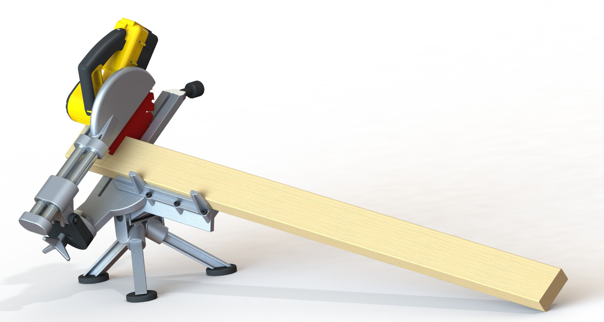
Fig.1 illustrates the saw in use, the overall method of operation should be familiar to any framer as it supports 2x lumber in similar manner they do when cutting off of their foot, where the lumber is laid back roughly forty five degrees against their shins with the edge of the board supported by the top of their foot. This is a fast and proven method that allows the cutoff section of lumber to fall away safely without binding the saw blade. The primary features listed below along with their reasons; allow the saw shown above to duplicate this freehand technique with the accuracy and precision of a typical miter saw.
- Tilted saw deck: This saw is designed to be frequently moved, therefore its ergonomics have been optimized for use while resting on the floor. Accordingly, the deck is angled upward towards the user and raised slightly off the floor, allowing them to cut a board by merely bending at the waist as opposed to crouching down in front of a standard miter saw. In addition, angling the deck upward substantially decreases its horizontal footprint, allowing it to be easily stored.
- Pivoting saw deck: This feature allows the saw to operate independent of any accessories. It would be inefficient if a miter saw stand or support blocks had to be set up every time the saw was moved. The pivoting feature allows the ground to perform this function, as discussed in my previous proposal.
- Partial saw deck: This feature provides for an efficient compact design. Due to the ease of positioning this saw, it will be easy for the user to orient it such that only one side of the saw deck is needed. Equally as important, this feature allows the saw to be easily picked up and carried as the removed saw deck will not bump their legs and also allow their arms to hang naturally to their sides during the process.
- Tripod stand: This feature provides stability over varied terrain. Just as the saw must be easily picked up, it must be just as easy to place back down. The tripod stand will allow the saw to be easily positioned and remain stable when placed on uneven terrain that exists when doing exterior decking or around debris that is typically scattered throughout a jobsite.
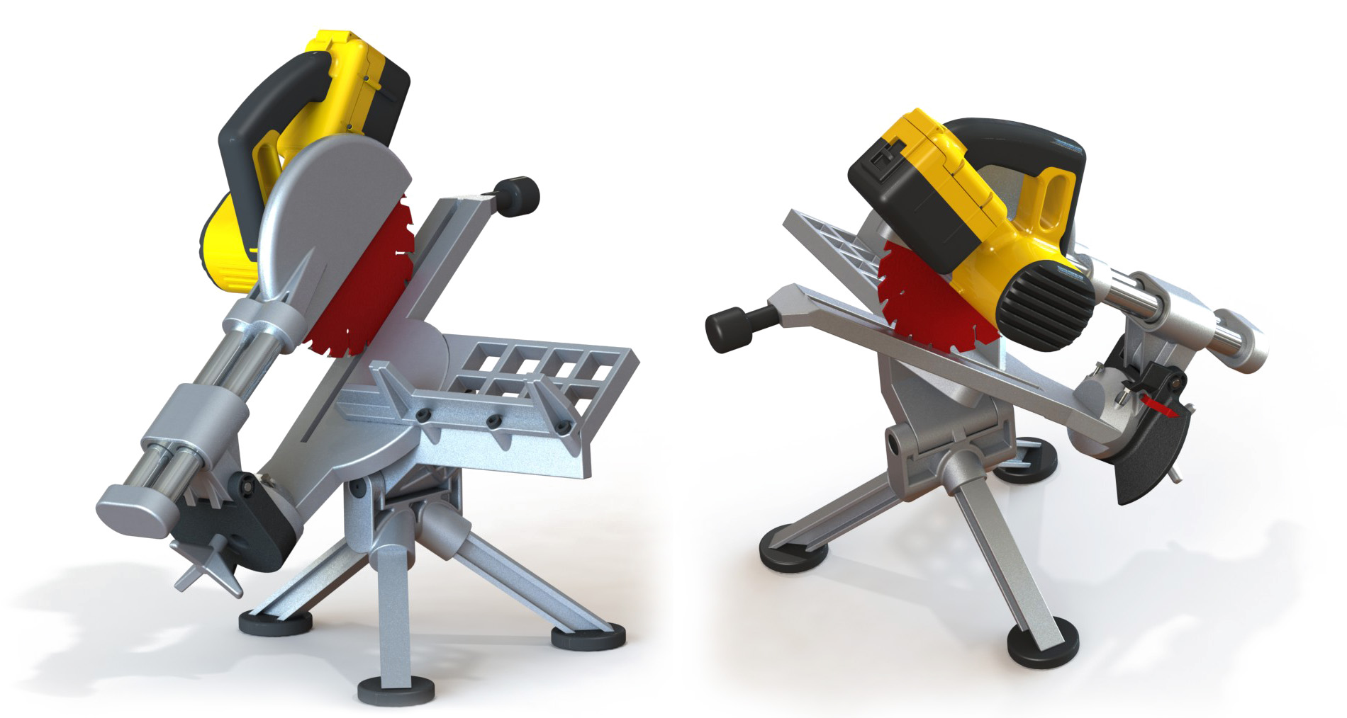
Fig.2 illustrates a few perspective views of the tool. The version shown above is modeled as a 36V cordless sliding action saw based on a 7 ¼ blade with the cutoff capacity of a standard 12” non-sliding miter saw. These parameters may vary to suit your needs, such as a 120V non-sliding version based on a 10” blade, without deviating from the design which is based on the pivoting saw deck and at least one of the other primary features listed on the previous page. However, the parameters shown above align well with this tools design objectives which are to cover that large area where either a miter saw or circular saw could be used but both portability and accuracy are required.
Any task that resides outside of this area such as cutting large header stock or crown, ripping lumber, etc… a large miter saw or circular saw would be used. This is an important point as this tool is not designed to replace either of these saws but one a contractor uses to augment their existing saws in order to significantly improve their productivity. This is an ideal scenario as it pushes the user to purchase your larger more profitable 12” sliding miter saw, in fact offering a combination package that included the saw shown here and your 12” sliding miter saw would be appealing to many contractors. This would provide them with both portability and capacity. A cordless package that included a 36V version of this saw and your 36V circular saw could also be popular.

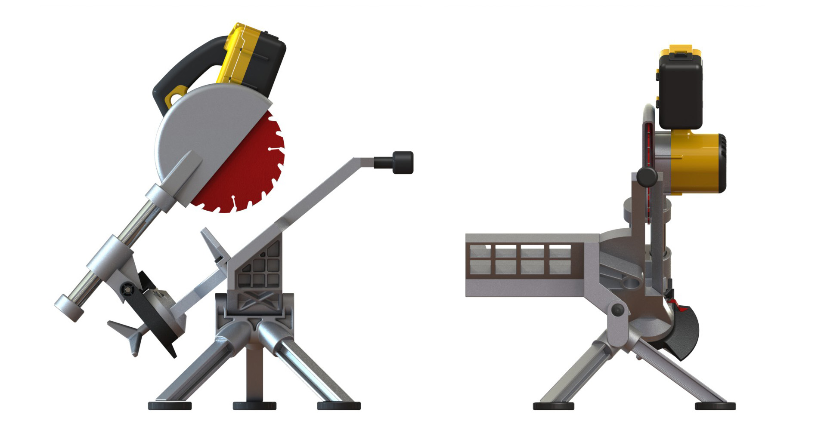
1
3
4
5
2
5a
Fig.3 illustrates a right side and frontal view of the disclosed tool. The right side view on the left side of Fig.3 shows the rear stop at 1 which in combination with the return spring (not shown) at pivot point 2 holds the upper assembly in the static or at rest position. The front stop at 3 limits the upper assembly’s clockwise rotation such that the blade and motor assembly is held at a constant height over the deck. Referring now to the right side of Fig.3, the deck stop at 4 serves to limit the decks’ clockwise rotation past horizontal. Regarding the location of the pivot point at 5, moving it to the right closer to the upper assembly’s center of gravity would reduce the force that returns the deck to the horizontal position. Consequently, moving it to the left would increase this force. However, this force can be either increased or decreased with linear or torsional springs at 5, allowing for more freedom in the pivot points location. For example, the use of a spring would allow the pivot point at 5 to be moved such that it was coincident with line 5a. The user could now firmly press boards that are flexible (trim), with their hands safely away from the blade, against the deck at 5a without this force creating any tendency to rotate it.

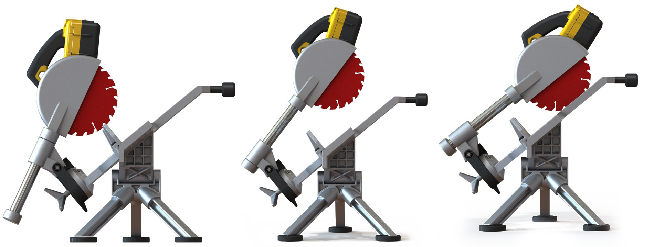
6
2
6
2
6
2

Fig.3 is a sequence of views that illustrates the saws cutting motion. The motor and blade assembly’s path from the static position on the left to engagement on the right deviates from the one taken on a standard sliding miter saw. This is because of the upper assemblies pivot point location at 2, which is traditionally located forward of the motor assembly at 6. Locating the pivot point as shown would result in an awkward movement for a traditional miter saw, requiring the user to pull the motor and blade assembly up and over the lumber. However, when operating the saw from above this path is a more natural and less restricting one. In addition, as the saw blade and motor assembly is drawn back its’ leverage about the pivot point increases. This will allow the weight of the assembly alone to counter the pivot points’ return spring and fall effortlessly into the position shown on the right. Finally, this location results in a more compact saw as the pivot point is located below the linear bearing assembly as opposed to in front of it. Of course the pivot point could be located traditionally if desired.
An option not shown but worth noting would be a simple latch mechanism that locked the deck in the horizontal position. This would increase the saws stability when short pieces of lumber or trim need to be cut. Other features not shown are the braking mechanism for the rotating deck, return springs, blade guards, etc… as these features are well known and can take on many forms common to the industry.

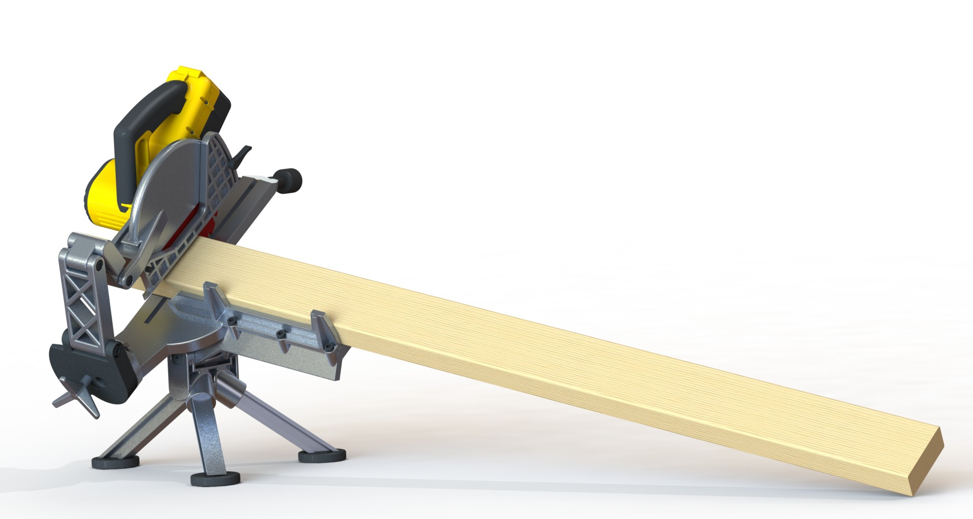

Fig.4 illustrates an optional extension mechanism. The mechanism used to increase the cutoff capacity in this version is similar to the mechanism used in Bosch’s axial glide miter saw. However, the mechanism shown above relies on a single articulated arm to control lateral movement and an abbreviated foot to control the height above the deck. While another articulated arm could be used to control the height of the saw above the deck, this would infringe Bosch’s potential patent. However, this would not be the case if the pivot that controlled the downward action of the saw were located at 2 as shown in Fig.3. Since the hinge linkage is not connecting the pivot block to the rotatable table. Either way, this type of linear extension mechanism fits perfectly with this tools design objectives as it reduces the overall size to a minimum. In fact, this mechanism is much better suited for this tool than a 12” sliding miter saw that will never be compact or portable.
Other optional configurations could include a version that allowed the deck to also rotate about another axis, for example one normal to the ground, which provided the saw with another degree of freedom. This would allow the saw to spin as well as tilt, where it could now quickly adapt to any lumber orientation. This configuration would work well with a version that used a fence that was able to vary the angle between itself and the blade as opposed to the typical rotating table. Another option would be to place the upper assembly pivot point on the opposite side of the rotating table such that the extension mechanism would now be attached to the rear of the saw blade and motor assembly. This would allow the lumber to be easily loaded from the front. However, a downside would be the ability to double the saws’ cross cut capacity by cutting a portion of a board, flipping it over and finishing the cut would no longer be an option.

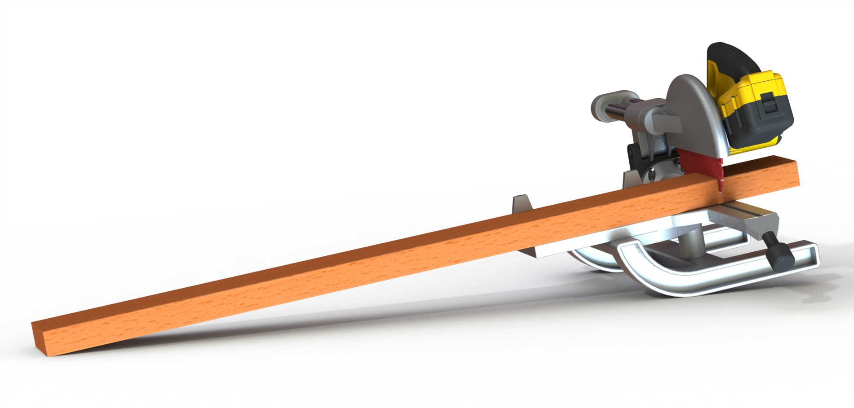
Fig.5 illustrates a version that implements a simple rocking chair feature to provide for the tilting abilities.

There are several compact miter saws based on 7 ¼ blades and while these saws are smaller and more compact than their full sized counterparts, they are still modeled after stationary miter saws with the same design objectives. It is for this reason users regard these saws as ones that are easier to store, pack up and take to the job site but once there they are set up as fixed cutoff stations just like their larger counterparts. While the saw disclosed here is also compact, its design objectives are quite different, where portability and independence from any accessories are the main goals. It is a saw that moves with the user as they go from one task to another on a jobsite, not one they have to repeatedly come back to.
This would allow a finishing contractor to move from one window to the next without having to reposition their cutting station every time they transitioned to a different room or floor level. Baseboard could be scattered throughout a room and knocked out in place. Framing contractors would also benefit as repeated trips back to the cutting station are so time consuming that most use a circular saw whenever possible with varying degrees of success. This saw would improve and provide more consistent performance without costing them valuable time. It is a “go to” saw that remodeling contractors could take throughout the house to knock out those small individual projects or punch list items. This saw appeals to a wide audience, targets a niche market without competition and while some of your smaller miter saws sales could be lost to this tool, so will the small miter saw sales of all your competitors. Finally, offering a combination package that included this tool with one of you 12” sliding miter saws would ensure that you impact their large miter saw market as well.

